Current Button – To Add New Print button – “ Print ISS Label “
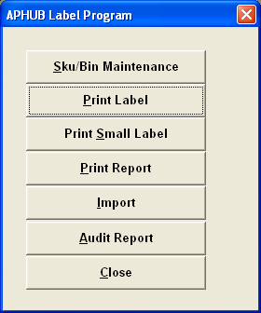

1.)To Remove from current Print Label on the “ Print Serial “, model & Serial No for normal printing usage. ( 1 print button)

2.)To apply for new ISS button.
Same function for ISS Print label with the serial no# field extend to 23 Digit
Different format of label detail assign
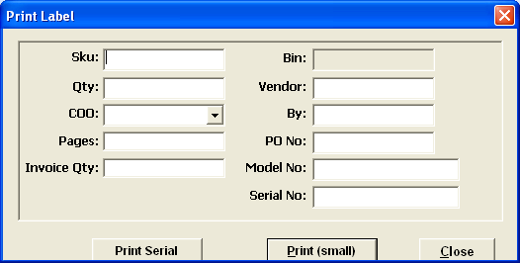

Sample of New label format request.

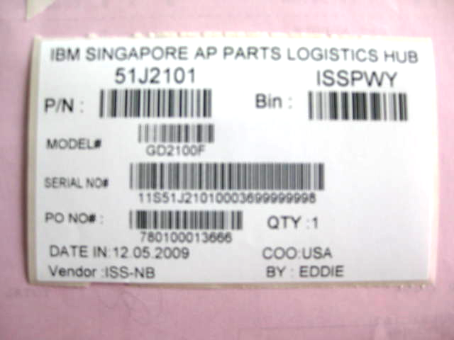

Current and New Sample view
